# **Hello World RESTful Web Service**

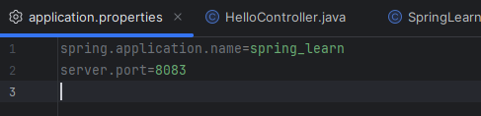

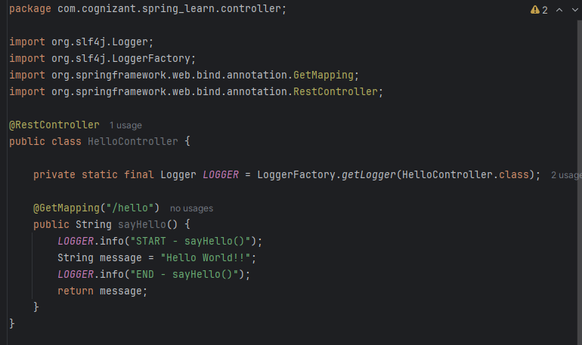

HelloController.java

Output on Intellij:

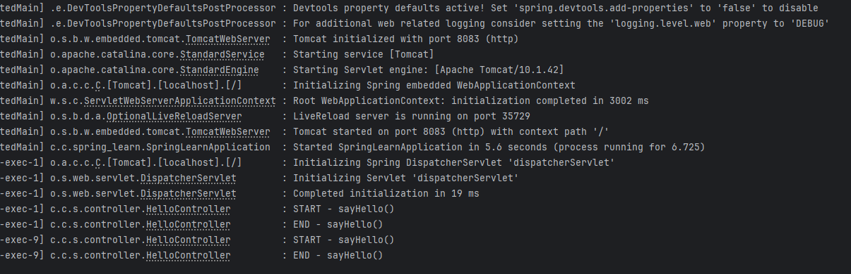

Output on chrome:

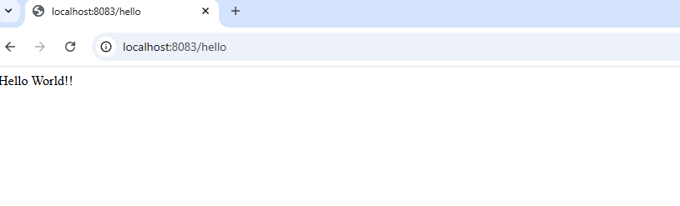

Output on Postman:

